**VMS Support Application User Manual**

**Registration in VMS Support Application**

1. Tap the VMS app icon at your smart phone and splash screen will appear.

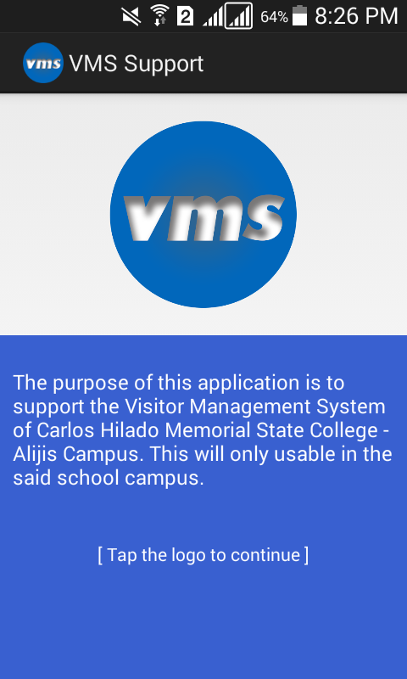

1. Fill-up the Server IP address and security code for validation of user and registration.

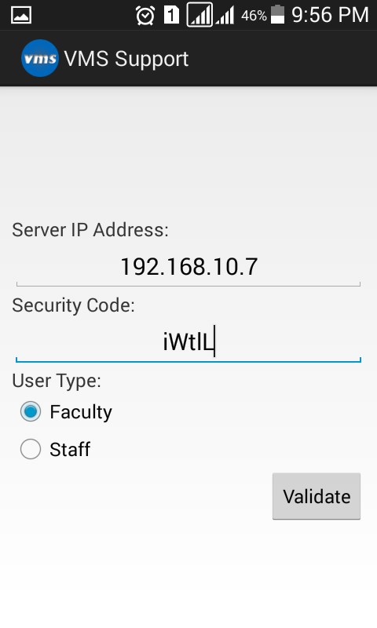

**Reading messages in VMS Support Application**

1. Click the Message icon to read messages.

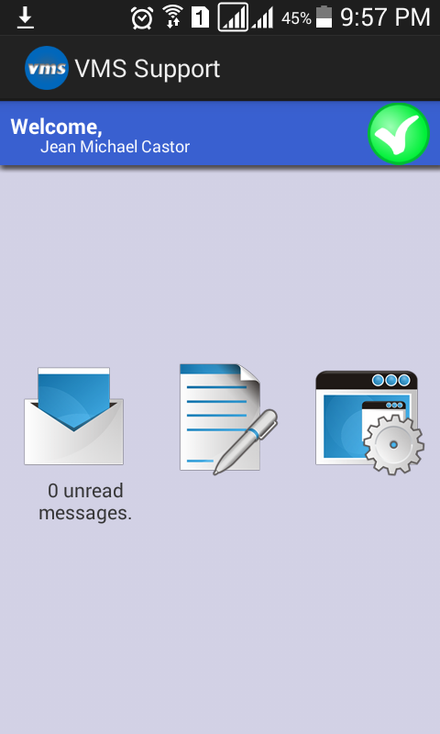

1. Click the one of the messages to view the full details of the messages.

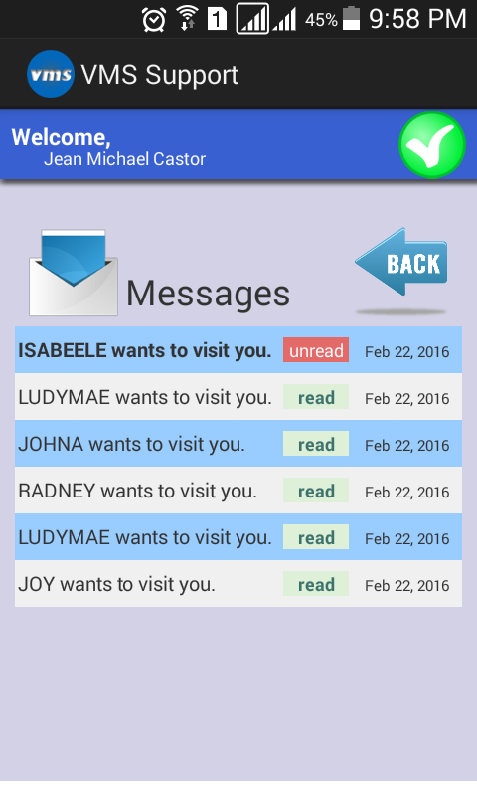

1. Scroll to bottom to accept or reject the visitor.

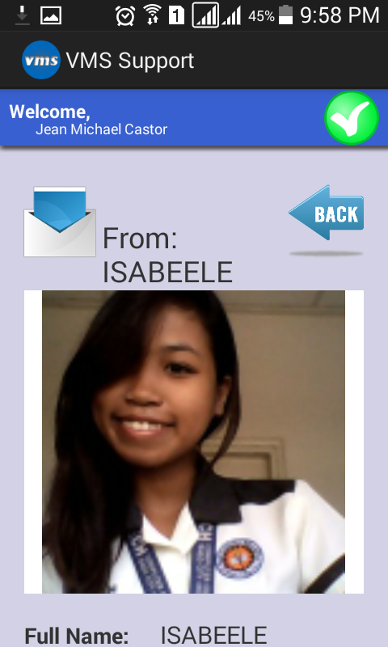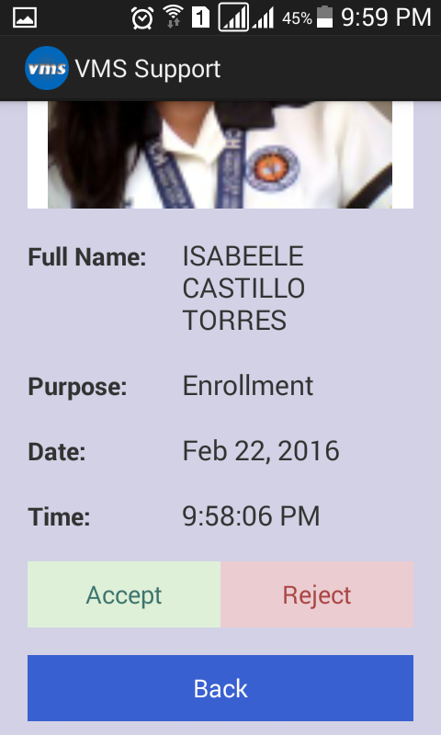

**Updating location using VMS Support Application**

1. Click the Write New Icon.
2. Select new location and write your message.

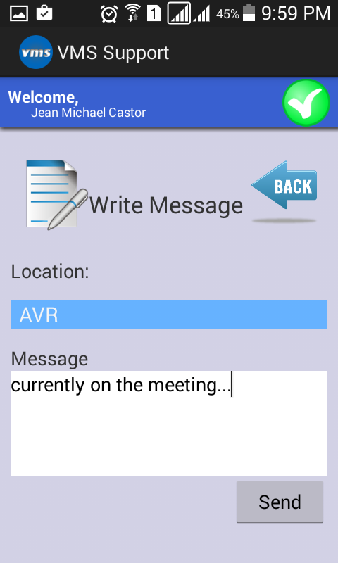

**Changing the Server (CVMS) Address in VMS Support Application**

1. Click the Settings Icon.
2. Enter the new Server IP Address.

